COMP2000 C1 Set Exercises

# Exercise 1

Create a UML diagram for the scenario description below.

* Identify all classes, attributes and relationships in the scenario.
* Identify a suitable design pattern using the scenario’s classes, attributes and relationships in the UML diagram.
* Place your UML diagram as an image in the answer section

## Scenario

A company needs a photo management app. The app display can change between a tiled list and a carousel of images, with a popup to display a single image when selected. Users can add, remove and rename photos and save them to the cloud. Users can add a vintage, technicolor, old paper or edge detect filter to a photo and share it to social media, including Facebook, Instagram and Twitter.

Photo management app

The app display can change from:

Tiled

Carousel – when user clicks on a photo a bigger image is shown

Users can add, remove, and rename photos and save them to the cloud

## Answer

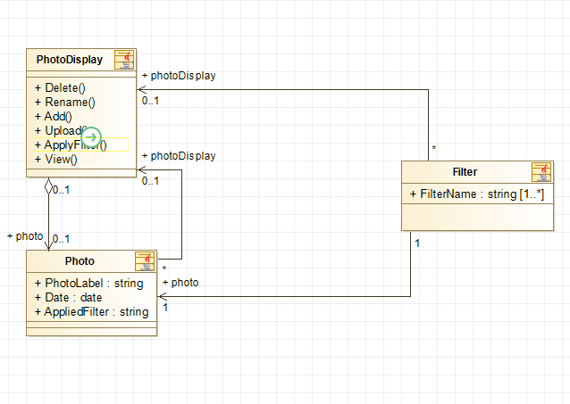

# Exercise 2

Create a UML diagram from the provided Java code below

* Identify all classes, interfaces, fields, methods and relationships and insert them into the diagram
* Place your UML diagram as an image in the answer section

## Java code

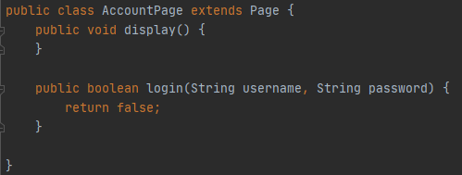

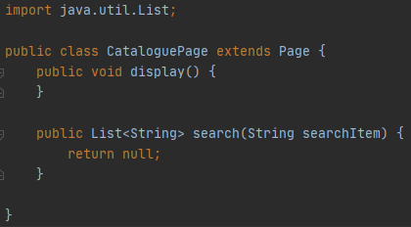

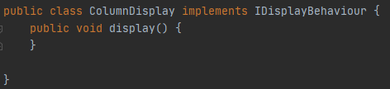

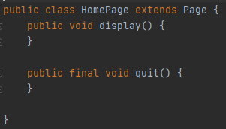

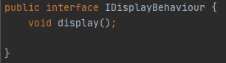

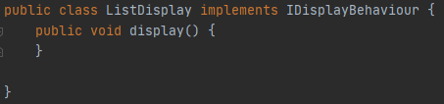

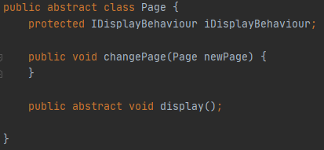

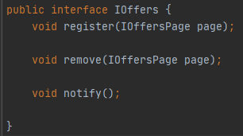

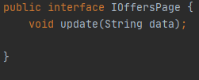

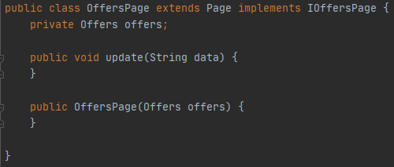

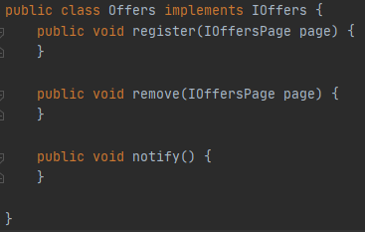

## Answer

# Exercise 3

Write test code for the provided UML diagram

* Generate or write the code in the provided UML diagram image
* Identify and implement appropriate tests for the code
  + Aim for 5-10 tests
  + Consider the flow of data
  + How do you check data correctness at each point in the program?
  + Add code statements in the classes to implement your tests
  + Write a test class to test your code
    - Please go over Session 2 for creating code tests
  + Output your results to the console
* Screenshot only your test class and your console output in the answer section
  + You will be marked on
    - Identifying which values change the most in the system
    - Applying appropriate tests for the type of data and how it is being used in the system

## UML diagram

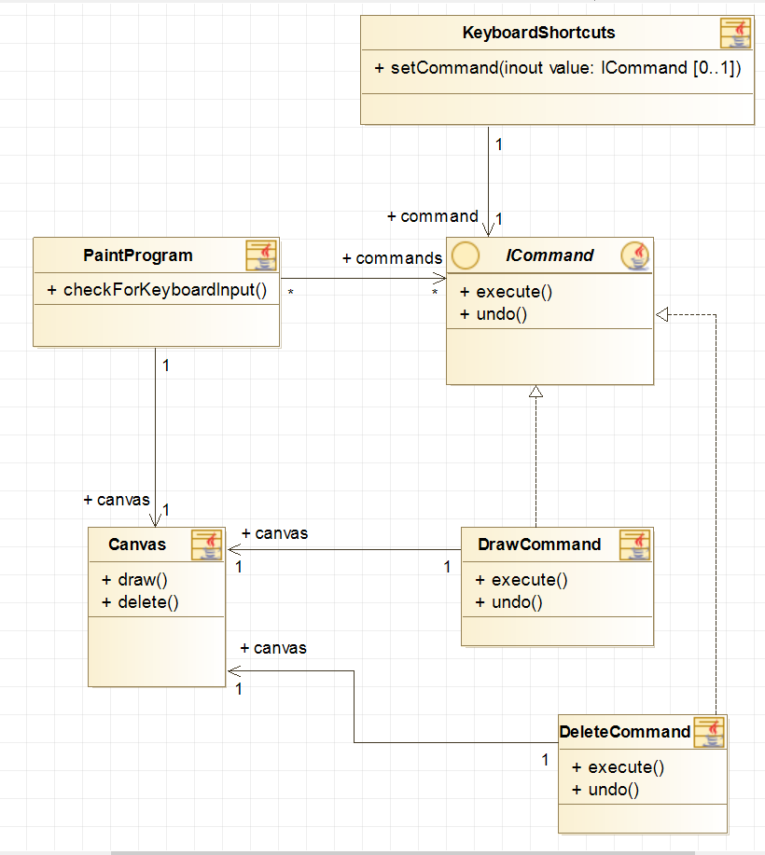

## Answer

# Exercise 4

Copy the following text into a text file called ‘data.txt’

|  |
| --- |
| Lorem ipsum dolor sit amet, consectetur adipiscing elit, sed do eiusmod tempor incididunt ut labore et dolore magna aliqua. Ut enim ad minim veniam, quis nostrud exercitation ullamco laboris nisi ut aliquip ex ea commodo consequat. Duis aute irure dolor in reprehenderit in voluptate velit esse cillum dolore eu fugiat nulla pariatur. Excepteur sint occaecat cupidatat non proident, sunt in culpa qui officia deserunt mollit anim id est laborum. |

Create an application with two GUI classes, they must have separate JPanels, each on one half of the window.

This exercise will implement simple threading by loading a file from one GUI and display in the other when completed loading.

## Panel 1

Add a button with a click event to load the text file into the class

Create a thread to listen for when the file loads, the thread runs when the file starts loading

## Panel 2

Create a text area to display the text when loaded

Create a listener for when the panel 1 Thread has finished

## Output

Panel 2 should display the loaded text in its text area

Provide a screenshot of the application window with the text file loaded

Provide a screenshot of your threading code, including the main method